***Nama : Jihad Rafsanjani  
Keterangan : Tugas Modul 7 Visualization with Google Looker Studio***

Dasboard

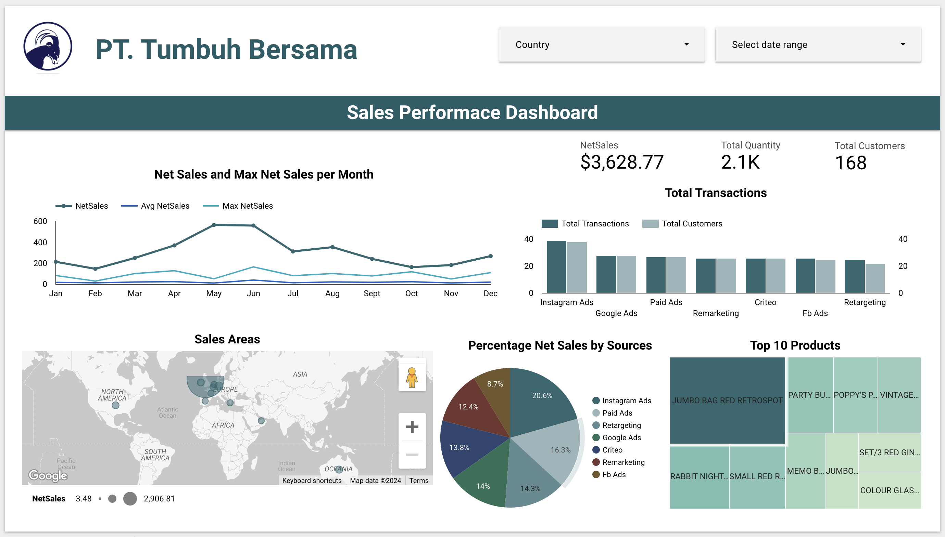

Link Dashboard : <https://lookerstudio.google.com/reporting/bfad19bd-9f61-4b3d-a0b1-037046a39f23>